Print from Mac OS X to Windows via TCP/IP

1.    Install "Print Services for Unix" on Windowswhich EagleRIP is installed.

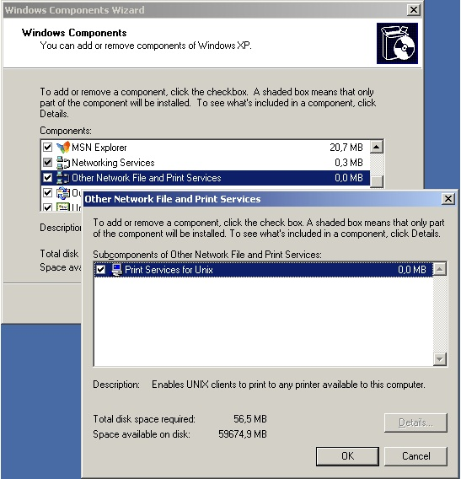

2.    Set the Startup type for the "TCP/IP Print Server" Service toAutomatic

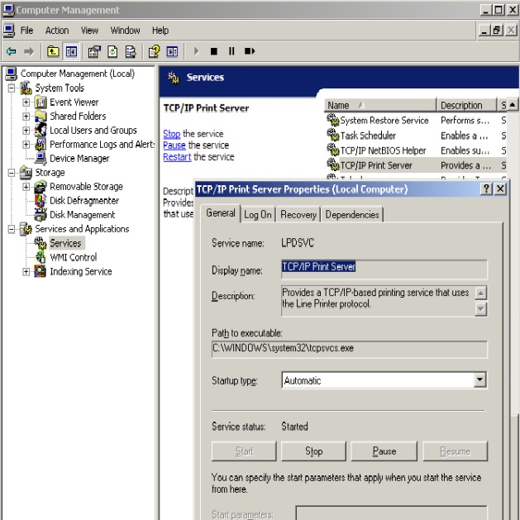

3.    Make a Windows Firewall exception on port 515 TCP

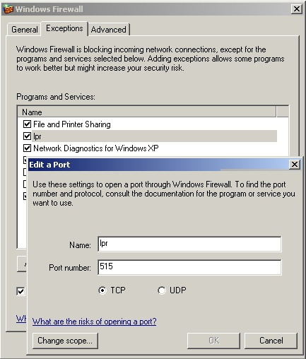

4.    Share your printer using a unique share-name

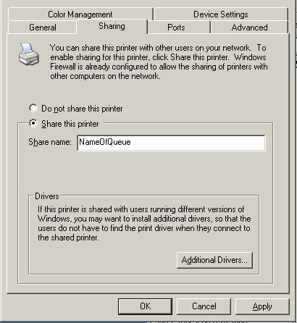

5.    Set the printer’s port to a NTPIPE printer, for example you havecreated an input in EagleRIP first (input name is “sample”)

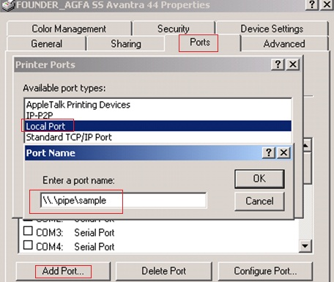

6.    Add your printer on Mac OS X using IP

       Protocol: Line Printer Daemon - LPD,  
       Input the IP address of your PC with the shared printer in"Address"  
       Input the shared-name in "Queue"  
       Name your printer in "Name" as you like  
       Select a PPD in "Print using" (You can generate a MAC PPD inEagleRIP, and copy this PPD to MAC)

